UNITED STATES
SECURITIES AND EXCHANGE COMMISSION
WASHINGTON, D.C. 20549

FORM 8-K

CURRENT REPORT

PURSUANT TO SECTION 13 OR 15(D) OF
THE SECURITIES EXCHANGE ACT OF 1934

Date of Report (Date of earliest event reported): September 23, 2026

Orange County Bancorp, Inc.
(Exact Name of Registrant as Specified in Charter)

Delaware | 001-40711 | 26-1135778
(State or Other Jurisdiction) | (Commission File No.) | (I.R.S. Employer
of Incorporation) |  | Identification No.)

212 Dolson Avenue, Middletown, New York | 10940
(Address of Principal Executive Offices) | (Zip Code)

Registrant's telephone number, including area code: (845) 341-5000

Not Applicable
(Former name or former address, if changed since last report)

Check the appropriate box below if the Form 8-K filing is intended to simultaneously satisfy the filing obligation of the registrant under any of the following provisions (see General Instruction A.2. below):

 | ☐ | Written communications pursuant to Rule 425 under the Securities Act (17 CFR 230.425)

 | ☐ | Soliciting material pursuant to Rule 14a-12 under the Exchange Act (17 CFR 240.14a-12)

 | ☐ | Pre-commencement communications pursuant to Rule 14d-2(b) under the Exchange Act (17 CFR 240.14d-2(b))

 | ☐ | Pre-commencement communications pursuant to Rule 13e-4(c) under the Exchange Act (17 CFR 240.13e-4(c))

Securities registered pursuant to Section 12(b) of the Act:

Title of each class |  | Trading  Symbol(s) |  | Name of each exchange on which  registered
Common Stock, par value $0.25 |  | OBT |  | The Nasdaq Stock Market, LLC

Indicate by check mark whether the registrant is an emerging growth company as defined in Rule 405 of the Securities Act of 1933 (§230.405 of this chapter) or Rule 12b-2 of the Securities Exchange Act of 1934 (§240.12b-2 of this chapter).

Emerging growth company x

If an emerging growth company, indicate by check mark if the registrant has elected not to use the extended transition period for complying with any new or revised financial accounting standards provided pursuant to Section 13(a) of the Exchange Act. ☐

Item 7.01 | Regulation FD Disclosure

On September 23, 2026, Orange County Bancorp, Inc. (the “Company”), parent company of Orange Bank & Trust Company and Orange Investment Advisors, Inc. made available and distributed to analysts and prospective investors a slide presentation. The slide presentation will be reviewed with certain analysts and certain institutional investors at the Stephens Bank Forum 2026 on September 24, 2026. The presentation materials include information regarding the Company’s operating and growth strategies and financial performance. The slide presentation is furnished in this Current Report on Form 8-K, pursuant to this Item 7.01, as Exhibit 99.1, and is incorporated herein by reference.

This Current Report and the information included below and furnished as exhibits hereto shall not be deemed to be “filed” for purposes of Section 18 of the Securities Exchange Act of 1934, as amended (“Exchange Act”), nor shall it be incorporated by reference into a filing under the Securities Act of 1933, as amended, or the Exchange Act, except as expressly set forth by specific reference in such a filing. The furnishing of the information in this Current Report is not intended to, and does not, constitute a determination or admission by the Company that the information in this report is material or complete, or that investors should consider this information before making an investment decision with respect to any security of the Company or any of its affiliates.

Item 9.01 | Financial Statements and Exhibits

 | (a) | Financial statements of businesses acquired. None.
 | (b) | Pro forma financial information. None.
 | (c) | Shell company transactions: None.
 | (d) | Exhibits.
 |  | 99.1 | Presentation Materials of Orange County Bancorp, Inc.
 |  | 104 | Cover Page Interactive Data File (embedded within the Inline XBRL document)

SIGNATURES

Pursuant to the requirements of the Securities Exchange Act of 1934, the registrant has duly caused this report to be signed on its behalf by the undersigned, hereunto duly authorized.

 | ORANGE COUNTY BANCORP, INC.
DATE: September 23, 2026 | By: | /s/ Michael Lesler
 |  | Michael Lesler
 |  | Executive Vice President, Chief Financial Officer

Exhibit 99.1

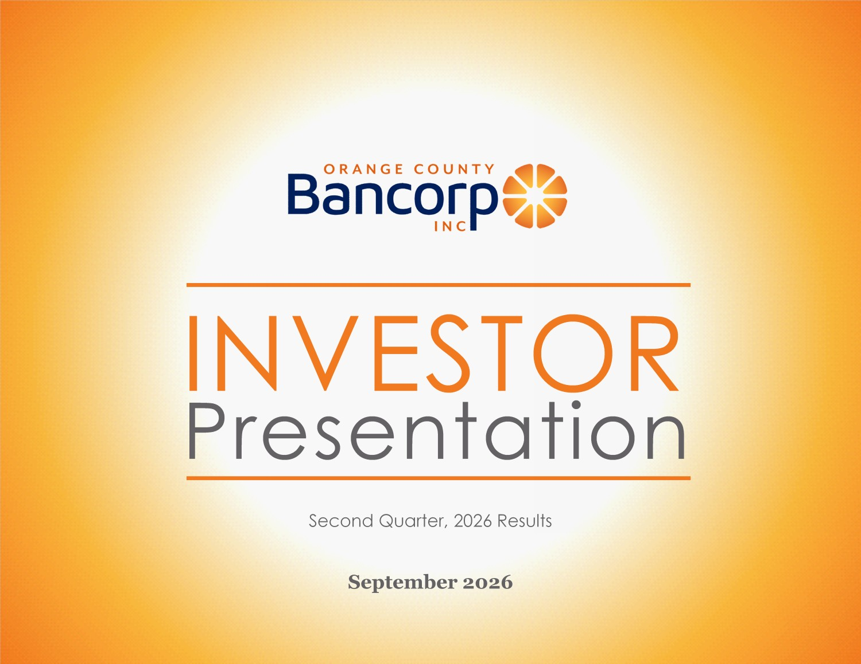
INVESTOR Presentation September 2026 Second Quarter, 2026 Results

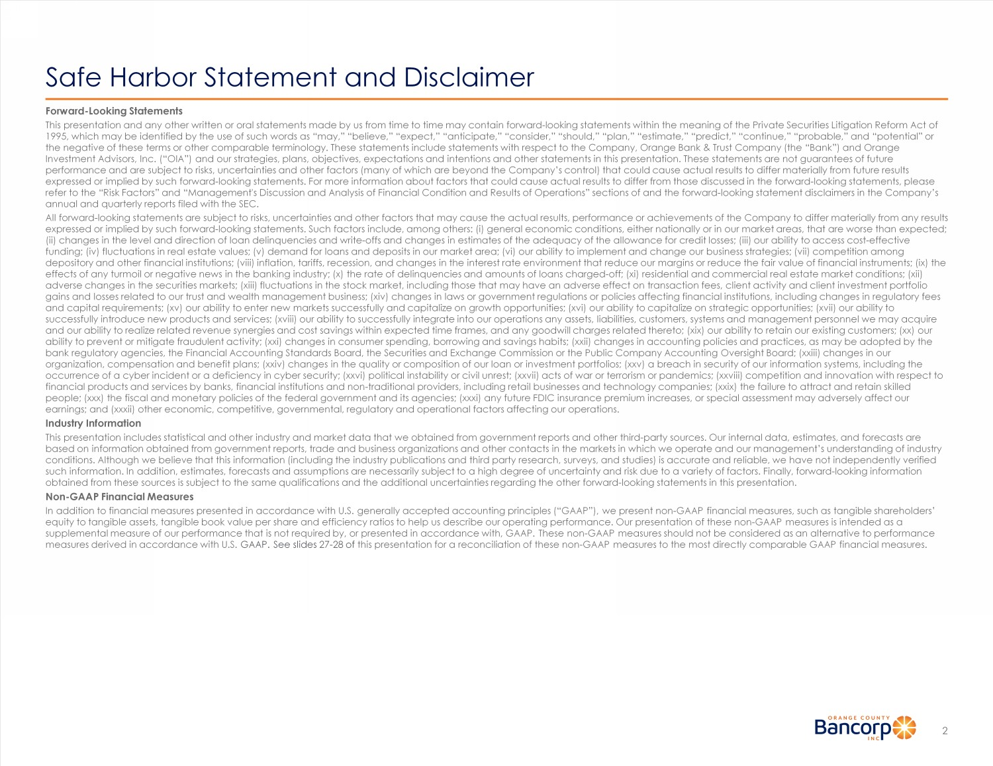
Safe Harbor Statement and Disclaimer Forward - Looking Statements This presentation and any other written or oral statements made by us from time to time may contain forward - looking statements w ithin the meaning of the Private Securities Litigation Reform Act of 1995, which may be identified by the use of such words as “may,” “believe,” “expect,” “anticipate,” “consider,” “should,” “pl an, ” “estimate,” “predict,” “continue,” “probable,” and “potential” or the negative of these terms or other comparable terminology. These statements include statements with respect to the Company, Or ange Bank & Trust Company (the “Bank”) and Orange Investment Advisors, Inc. (“OIA”) and our strategies, plans, objectives, expectations and intentions and other statements in thi s presentation. These statements are not guarantees of future performance and are subject to risks, uncertainties and other factors (many of which are beyond the Company’s control) that c oul d cause actual results to differ materially from future results expressed or implied by such forward - looking statements. For more information about factors that could cause actual results to d iffer from those discussed in the forward - looking statements, please refer to the “Risk Factors” and “Management's Discussion and Analysis of Financial Condition and Results of Operations” secti ons of and the forward - looking statement disclaimers in the Company’s annual and quarterly reports filed with the SEC. All forward - looking statements are subject to risks, uncertainties and other factors that may cause the actual results, performa nce or achievements of the Company to differ materially from any results expressed or implied by such forward - looking statements. Such factors include, among others: (i) general economic conditions, ei ther nationally or in our market areas, that are worse than expected; (ii) changes in the level and direction of loan delinquencies and write - offs and changes in estimates of the adequacy of the all owance for credit losses; (iii) our ability to access cost - effective funding; (iv) fluctuations in real estate values; (v) demand for loans and deposits in our market area; (vi) our ability to i mpl ement and change our business strategies; (vii) competition among depository and other financial institutions; (viii) inflation, tariffs, recession, and changes in the interest rate environme nt that reduce our margins or reduce the fair value of financial instruments; (ix) the effects of any turmoil or negative news in the banking industry; (x) the rate of delinquencies and amounts of loans charged - off; (xi) residential and commercial real estate market conditions; (xii) adverse changes in the securities markets; (xiii) fluctuations in the stock market, including those that may have an adverse eff ect on transaction fees, client activity and client investment portfolio gains and losses related to our trust and wealth management business; (xiv) changes in laws or government regulations or poli cie s affecting financial institutions, including changes in regulatory fees and capital requirements; (xv) our ability to enter new markets successfully and capitalize on growth opportunities; (xvi) ou r a bility to capitalize on strategic opportunities; (xvii) our ability to successfully introduce new products and services; (xviii) our ability to successfully integrate into our operations any asset s, liabilities, customers, systems and management personnel we may acquire and our ability to realize related revenue synergies and cost savings within expected time frames, and any goodwill charges r ela ted thereto; (xix) our ability to retain our existing customers; (xx) our ability to prevent or mitigate fraudulent activity; (xxi) changes in consumer spending, borrowing and savings habits; (xxii) cha nges in accounting policies and practices, as may be adopted by the bank regulatory agencies, the Financial Accounting Standards Board, the Securities and Exchange Commission or the Public Comp any Accounting Oversight Board; (xxiii) changes in our organization, compensation and benefit plans; (xxiv) changes in the quality or composition of our loan or investment portfoli os; (xxv) a breach in security of our information systems, including the occurrence of a cyber incident or a deficiency in cyber security; (xxvi) political instability or civil unrest; (xxvii) acts of war or terrorism or pandemics; (xxviii) competition and innovation with respect to financial products and services by banks, financial institutions and non - traditional providers, including retail businesses and technology companies; (xxix) the failure to attract and retain skilled people; (xxx) the fiscal and monetary policies of the federal government and its agencies; (xxxi) any future FDIC insurance p rem ium increases, or special assessment may adversely affect our earnings; and (xxxii) other economic, competitive, governmental, regulatory and operational factors affecting our operations. Industry Information This presentation includes statistical and other industry and market data that we obtained from government reports and other thi rd - party sources. Our internal data, estimates, and forecasts are based on information obtained from government reports, trade and business organizations and other contacts in the markets in whi ch we operate and our management’s understanding of industry conditions. Although we believe that this information (including the industry publications and third party research, surveys, an d studies) is accurate and reliable, we have not independently verified such information. In addition, estimates, forecasts and assumptions are necessarily subject to a high degree of uncertainty a nd risk due to a variety of factors. Finally, forward - looking information obtained from these sources is subject to the same qualifications and the additional uncertainties regarding the other forwar d - l ooking statements in this presentation. Non - GAAP Financial Measures In addition to financial measures presented in accordance with U.S. generally accepted accounting principles (“GAAP”), we pre sen t non - GAAP financial measures, such as tangible shareholders’ equity to tangible assets, tangible book value per share and efficiency ratios to help us describe our operating performance. Ou r presentation of these non - GAAP measures is intended as a supplemental measure of our performance that is not required by, or presented in accordance with, GAAP. These non - GAAP measures should not be considered as an alternative to performance measures derived in accordance with U.S. GAAP. See slides 27 - 28 of this presentation for a reconciliation of these non - GAAP measures to the most directly comparable GAAP financial measures. 2

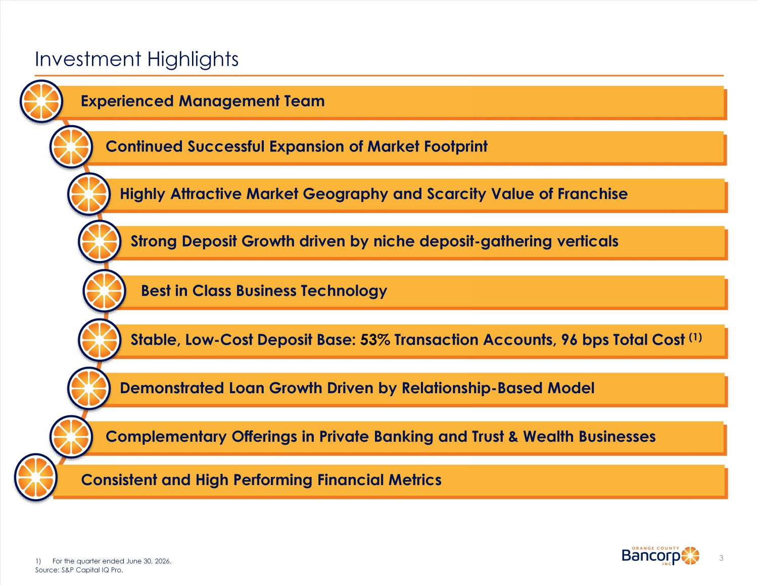
Investment Highlights 3 1) For the quarter ended June 30, 2026. Source: S&P Capital IQ Pro. Experienced Management Team Continued Successful Expansion of Market Footprint Highly Attractive Market Geography and Scarcity Value of Franchise Strong Deposit Growth driven by niche deposit - gathering verticals Stable, Low - Cost Deposit Base : 53% Transaction Accounts, 96 bps Total Cost (1) Demonstrated Loan Growth Driven by Relationship - Based Model Complementary Offerings in Private Banking and Trust & Wealth Businesses Consistent and High Performing Financial Metrics Best in Class Business Technology

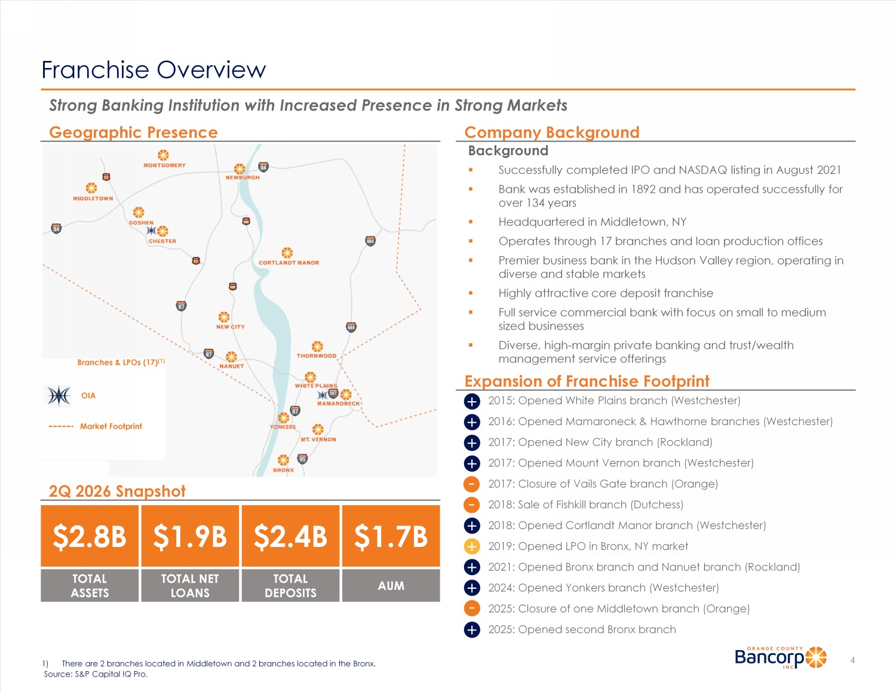
Franchise Overview 4 1) There are 2 branches located in Middletown and 2 branches located in the Bronx. Source: S&P Capital IQ Pro. Background ▪ Successfully completed IPO and NASDAQ listing in August 2021 ▪ Bank was established in 1892 and has operated successfully for over 134 years ▪ Headquartered in Middletown, NY ▪ Operates through 17 branches and loan production offices ▪ Premier business bank in the Hudson Valley region, operating in diverse and stable markets ▪ Highly attractive core deposit franchise ▪ Full service commercial bank with focus on small to medium sized businesses ▪ Diverse, high - margin private banking and trust/wealth management service offerings Strong Banking Institution with Increased Presence in Strong Markets Geographic Presence $1.9B TOTAL NET LOANS Company Background 2Q 2026 Snapshot - + + + + + + + - - 2015: Opened White Plains branch (Westchester) 2016: Opened Mamaroneck & Hawthorne branches (Westchester) 2017: Opened New City branch (Rockland) 2017: Opened Mount Vernon branch (Westchester) 2017: Closure of Vails Gate branch (Orange) 2018: Sale of Fishkill branch (Dutchess) 2018: Opened Cortlandt Manor branch (Westchester) 2019: Opened LPO in Bronx, NY market 2021: Opened Bronx branch and Nanuet branch (Rockland) 2024: Opened Yonkers branch (Westchester) 2025: Closure of one Middletown branch (Orange) 2025: Opened second Bronx branch Branches & LPOs (17) (1) Market Footprint Expansion of Franchise Footprint OIA + $2.4B TOTAL DEPOSITS $2.8B TOTAL ASSETS $1.7B AUM +

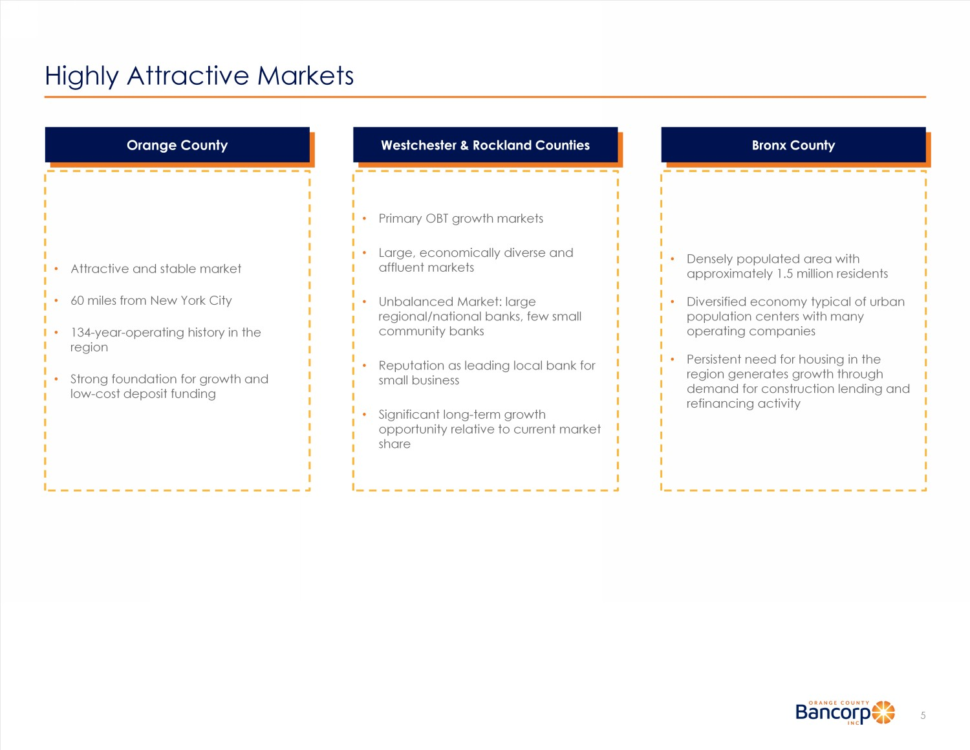
Highly Attractive Markets 5 Orange County Westchester & Rockland Counties Bronx County • Attractive and stable market • 60 miles from New York City • 134 - year - operating history in the region • Strong foundation for growth and low - cost deposit funding • Primary OBT growth markets • Large, economically diverse and affluent markets • Unbalanced Market: large regional/national banks, few small community banks • Reputation as leading local bank for small business • Significant long - term growth opportunity relative to current market share • Densely populated area with approximately 1.5 million residents • Diversified economy typical of urban population centers with many operating companies • Persistent need for housing in the region generates growth through demand for construction lending and refinancing activity

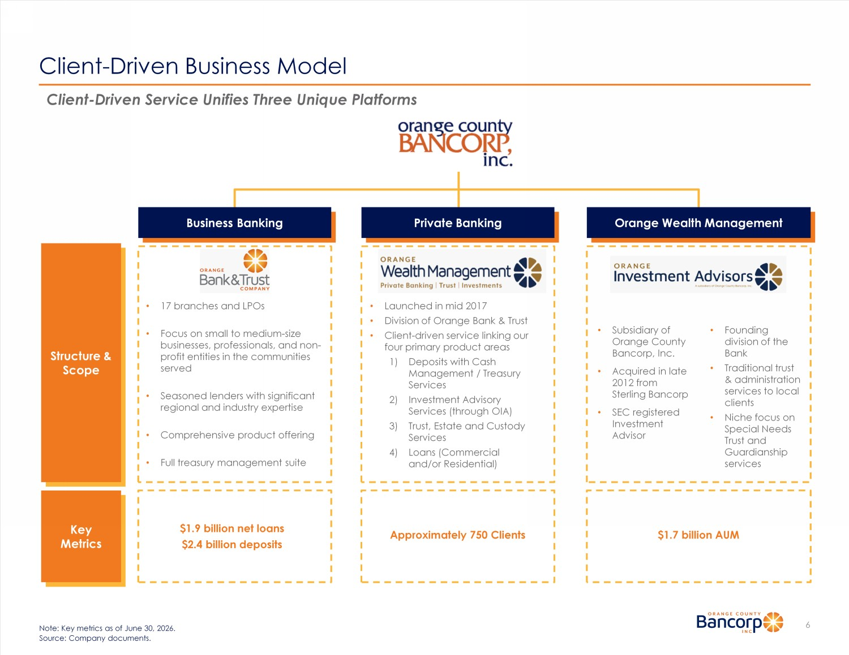
Structure & Scope Client - Driven Business Model 6 Business Banking Orange Wealth Management • 17 branches and LPOs • Focus on small to medium - size businesses, professionals, and non - profit entities in the communities served • Seasoned lenders with significant regional and industry expertise • Comprehensive product offering • Full treasury management suite Key Metrics $1.9 billion net loans $2.4 billion deposits • Launched in mid 2017 • Division of Orange Bank & Trust • Client - driven service linking our four primary product areas 1) Deposits with Cash Management / Treasury Services 2) Investment Advisory Services (through OIA) 3) Trust, Estate and Custody Services 4) Loans (Commercial and/or Residential) Approximately 750 Clients • Subsidiary of Orange County Bancorp, Inc. • Acquired in late 2012 from Sterling Bancorp • SEC registered Investment Advisor $1.7 billion AUM • Founding division of the Bank • Traditional trust & administration services to local clients • Niche focus on Special Needs Trust and Guardianship services Note: Key metrics as of June 30, 2026. Source: Company documents. Client - Driven Service Unifies Three Unique Platforms Private Banking

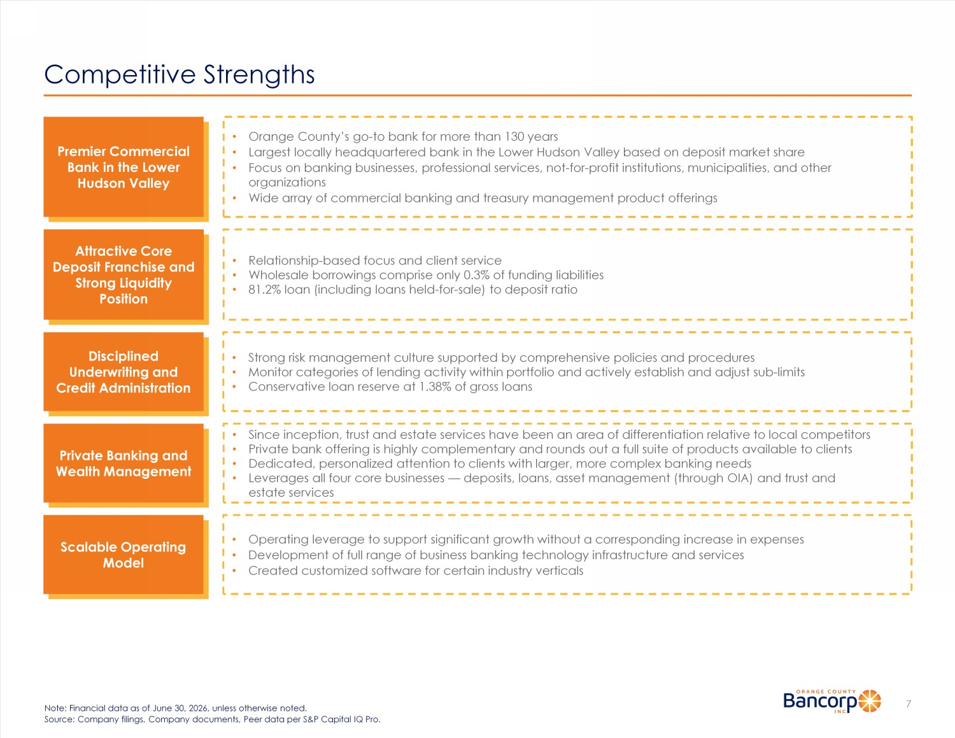
Competitive Strengths 7 Note: Financial data as of June 30, 2026, unless otherwise noted. Source: Company filings, Company documents, Peer data per S&P Capital IQ Pro. Premier Commercial Bank in the Lower Hudson Valley • Orange County’s go - to bank for more than 130 years • Largest locally headquartered bank in the Lower Hudson Valley based on deposit market share • Focus on banking businesses, professional services, not - for - profit institutions, municipalities, and other organizations • Wide array of commercial banking and treasury management product offerings Attractive Core Deposit Franchise and Strong Liquidity Position • Relationship - based focus and client service • Wholesale borrowings comprise only 0.3% of funding liabilities • 81.2% loan (including loans held - for - sale) to deposit ratio Scalable Operating Model • Operating leverage to support significant growth without a corresponding increase in expenses • Development of full range of business banking technology infrastructure and services • Created customized software for certain industry verticals Private Banking and Wealth Management • Since inception, trust and estate services have been an area of differentiation relative to local competitors • Private bank offering is highly complementary and rounds out a full suite of products available to clients • Dedicated, personalized attention to clients with larger, more complex banking needs • Leverages all four core businesses — deposits, loans, asset management (through OIA) and trust and estate services Disciplined Underwriting and Credit Administration • Strong risk management culture supported by comprehensive policies and procedures • Monitor categories of lending activity within portfolio and actively establish and adjust sub - limits • Conservative loan reserve at 1.38% of gross loans

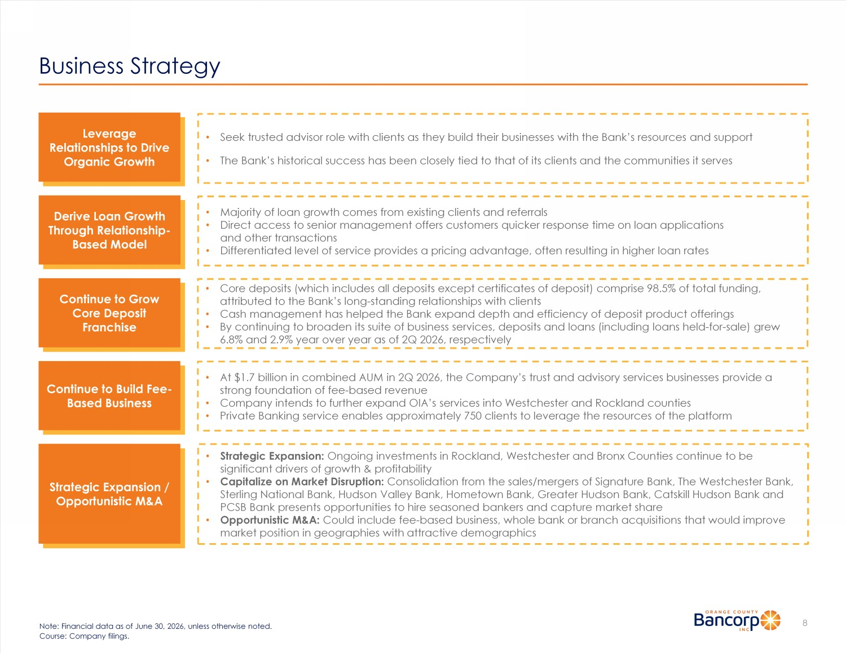
Business Strategy 8 Note: Financial data as of June 30, 2026, unless otherwise noted. Course: Company filings. Leverage Relationships to Drive Organic Growth Derive Loan Growth Through Relationship - Based Model Continue to Grow Core Deposit Franchise Continue to Build Fee - Based Business Strategic Expansion / Opportunistic M&A • Seek trusted advisor role with clients as they build their businesses with the Bank’s resources and support • The Bank’s historical success has been closely tied to that of its clients and the communities it serves • Majority of loan growth comes from existing clients and referrals • Direct access to senior management offers customers quicker response time on loan applications and other transactions • Differentiated level of service provides a pricing advantage, often resulting in higher loan rates • Core deposits (which includes all deposits except certificates of deposit) comprise 98.5% of total funding, attributed to the Bank’s long - standing relationships with clients • Cash management has helped the Bank expand depth and efficiency of deposit product offerings • By continuing to broaden its suite of business services, deposits and loans (including loans held - for - sale) grew 6.8% and 2.9% year over year as of 2Q 2026, respectively • Strategic Expansion: Ongoing investments in Rockland, Westchester and Bronx Counties continue to be significant drivers of growth & profitability • Capitalize on Market Disruption: Consolidation from the sales/mergers of Signature Bank, The Westchester Bank, Sterling National Bank, Hudson Valley Bank, Hometown Bank, Greater Hudson Bank, Catskill Hudson Bank and PCSB Bank presents opportunities to hire seasoned bankers and capture market share • Opportunistic M&A: Could include fee - based business, whole bank or branch acquisitions that would improve market position in geographies with attractive demographics • At $1.7 billion in combined AUM in 2Q 2026, the Company’s trust and advisory services businesses provide a strong foundation of fee - based revenue • Company intends to further expand OIA’s services into Westchester and Rockland counties • Private Banking service enables approximately 750 clients to leverage the resources of the platform

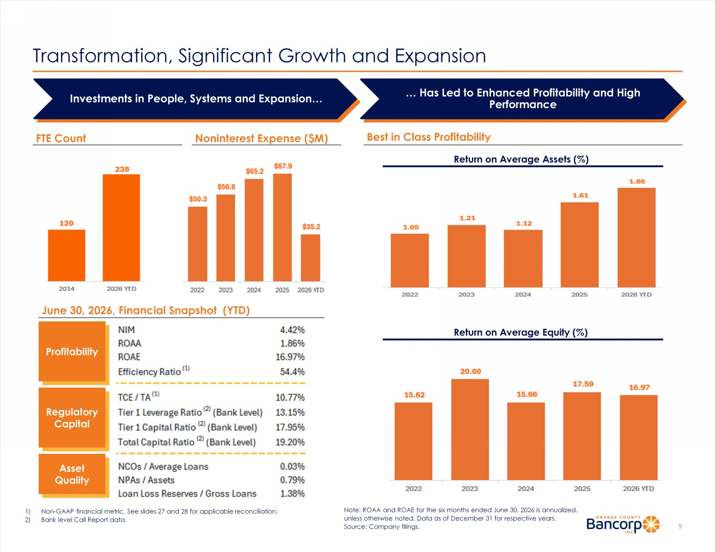
Transformation, Significant Growth and Expansion 9 Investments in People, Systems and Expansion… … Has Led to Enhanced Profitability and High Performance FTE Count Best in Class Profitability Return on Average Assets (%) Noninterest Expense ($M) 1) Non - GAAP financial metric. See slides 27 and 28 for applicable reconciliation. 2) Bank level Call Report data. Profitability Regulatory Capital Asset Quality June 30, 2026, Financial Snapshot (YTD) Note: ROAA and ROAE for the six months ended June 30, 2026 is annualized, unless otherwise noted. Data as of December 31 for respective years. Source: Company filings. Return on Average Equity (%)

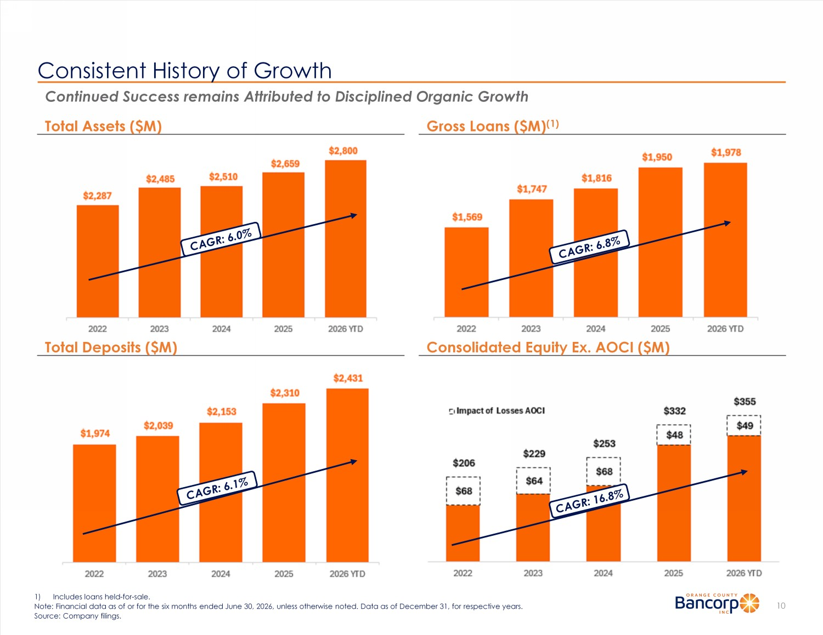
Consistent History of Growth 10 Continued Success remains Attributed to Disciplined Organic Growth Gross Loans ($M) (1) Total Assets ($M) Consolidated Equity Ex. AOCI ($M) Total Deposits ($M) 1) Includes loans held - for - sale. Note: Financial data as of or for the six months ended June 30, 2026, unless otherwise noted. Data as of December 31, for res pec tive years. Source: Company filings.

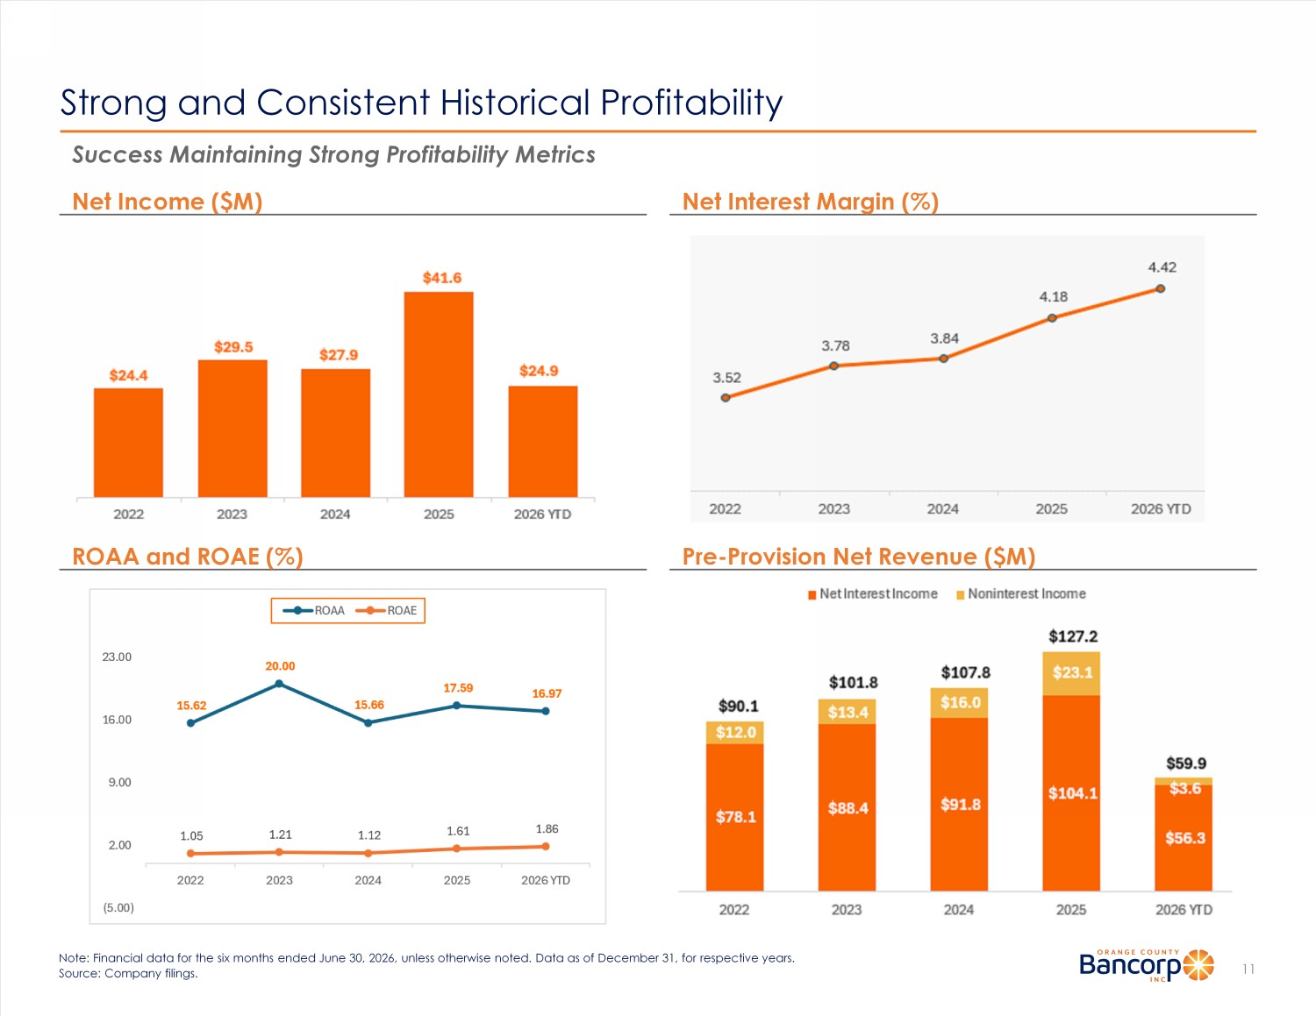
Strong and Consistent Historical Profitability 11 Net Interest Margin (%) Net Income ($M) Pre - Provision Net Revenue ($M) ROAA and ROAE (%) Success Maintaining Strong Profitabilit y Metrics Note: Financial data for the six months ended June 30, 2026, unless otherwise noted. Data as of December 31, for respective y ear s. Source: Company filings.

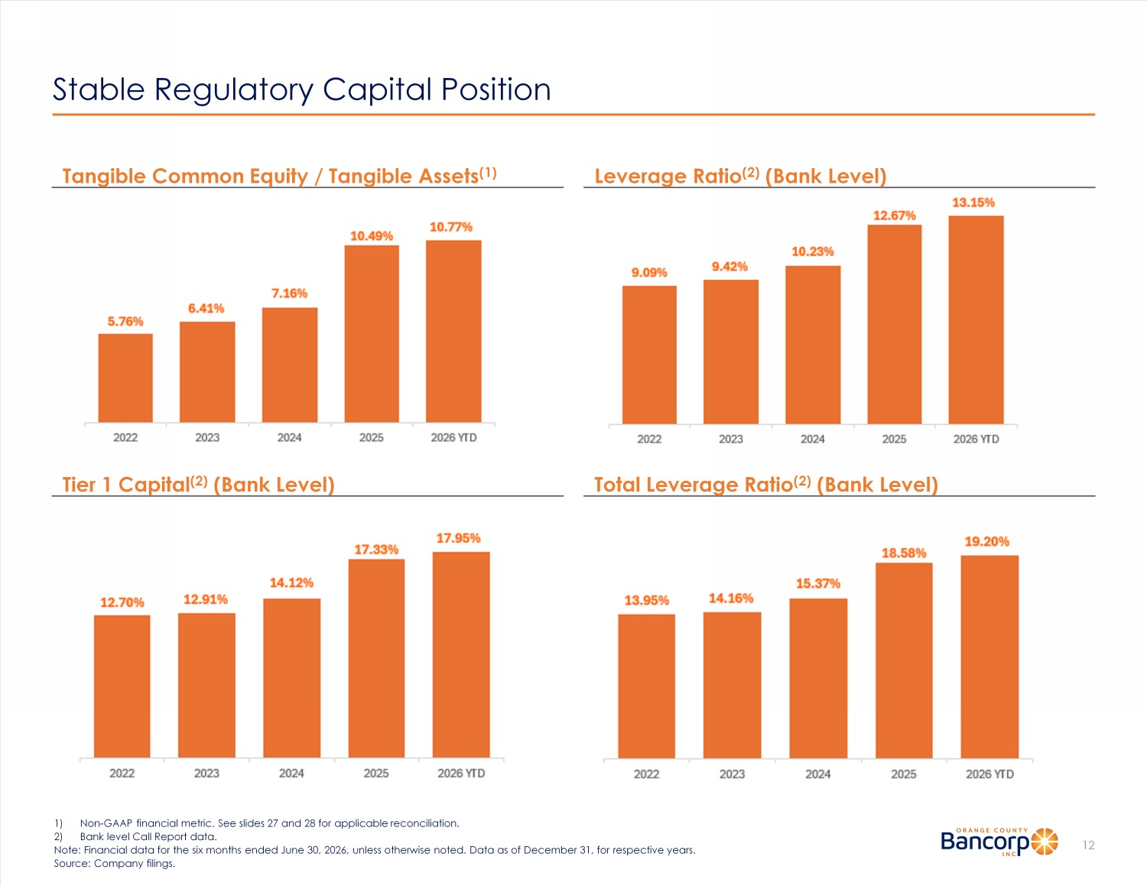
Stable Regulatory Capital Position 12 1) Non - GAAP financial metric. See slides 27 and 28 for applicable reconciliation. 2) Bank level Call Report data. Note: Financial data for the six months ended June 30, 2026, unless otherwise noted. Data as of December 31, for respective y ear s. Source: Company filings. Leverage Ratio (2) (Bank Level) Tangible Common Equity / Tangible Assets (1) Total Leverage Ratio (2) (Bank Level) Tier 1 Capital (2) (Bank Level)

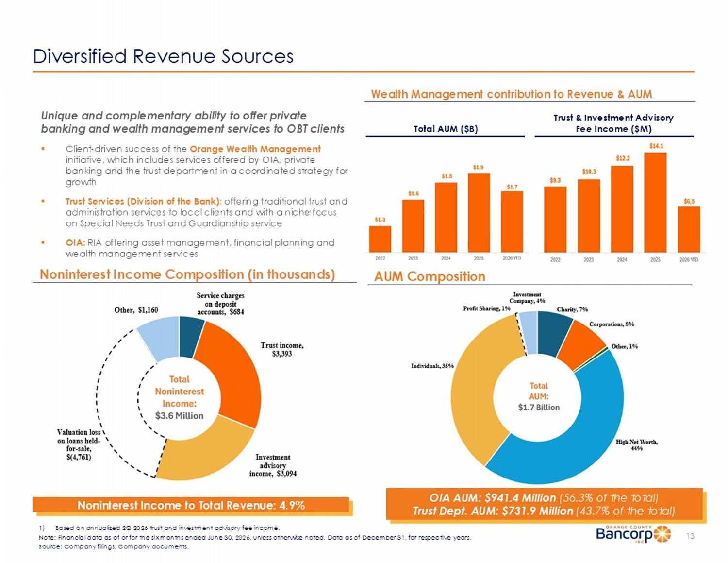
Diversified Revenue Sources 1) Based on annualized 2Q 2026 trust and investment advisory fee income. Noninterest Income Composition (in thousands) AUM Composition Unique and complementary ability to offer private banking and wealth management services to OBT clients ▪ Client - driven success of the Orange Wealth Management initiative, which includes services offered by OIA, private banking and the trust department in a coordinated strategy for growth ▪ Trust Services (Division of the Bank): offering traditional trust and administration services to local clients and with a niche focus on Special Needs Trust and Guardianship service ▪ OIA: RIA offering asset management, financial planning and wealth management services Wealth Management contribution to Revenue & AUM Noninterest Income to Total Revenue: 4.9% OIA AUM: $941.4 Million (56.3% of the total) Trust Dept. AUM: $675.3 Million (43.7% of the total) Total AUM ($B) 13 Trust & Investment Advisory Fee Income ($M) Note: Financial data as of or for the six months ended June 30, 2026, unless otherwise noted. Data as of December 31, for res pec tive years. Source: Company filings, Company documents.

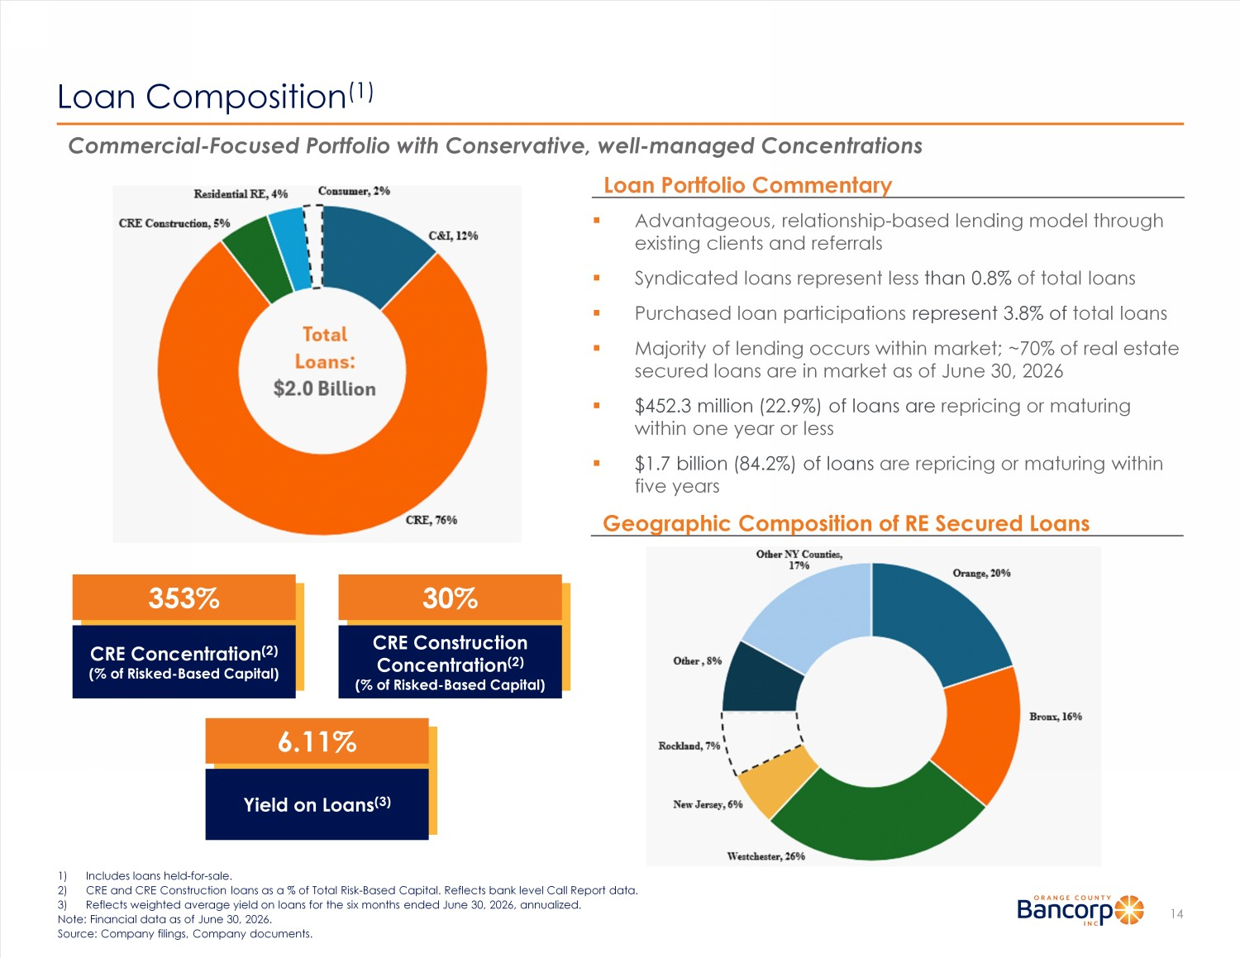
Loan Composition (1) 14 1) Includes loans held - for - sale. 2) CRE and CRE Construction loans as a % of Total Risk - Based Capital. Reflects bank level Call Report data. 3) Reflects weighted average yield on loans for the six months ended June 30, 2026, annualized. Note: Financial data as of June 30, 2026. Source: Company filings, Company documents. Commercial - Focused Portfolio with Conservative, well - managed Concentrations ▪ Advantageous, relationship - based lending model through existing clients and referrals ▪ Syndicated loans represent less than 0.8% of total loans ▪ Purchased loan participations represent 3.8% of total loans ▪ Majority of lending occurs within market; ~70% of real estate secured loans are in market as of June 30, 2026 ▪ $452.3 million (22.9%) of loans are repricing or maturing within one year or less ▪ $1.7 billion (84.2%) of loans are repricing or maturing within five years Geographic Composition of RE Secured Loans Loan Portfolio Commentary 6.11% Yield on Loans (3) 353% CRE Concentration (2) (% of Risked - Based Capital) 30% CRE Construction Concentration (2) (% of Risked - Based Capital)

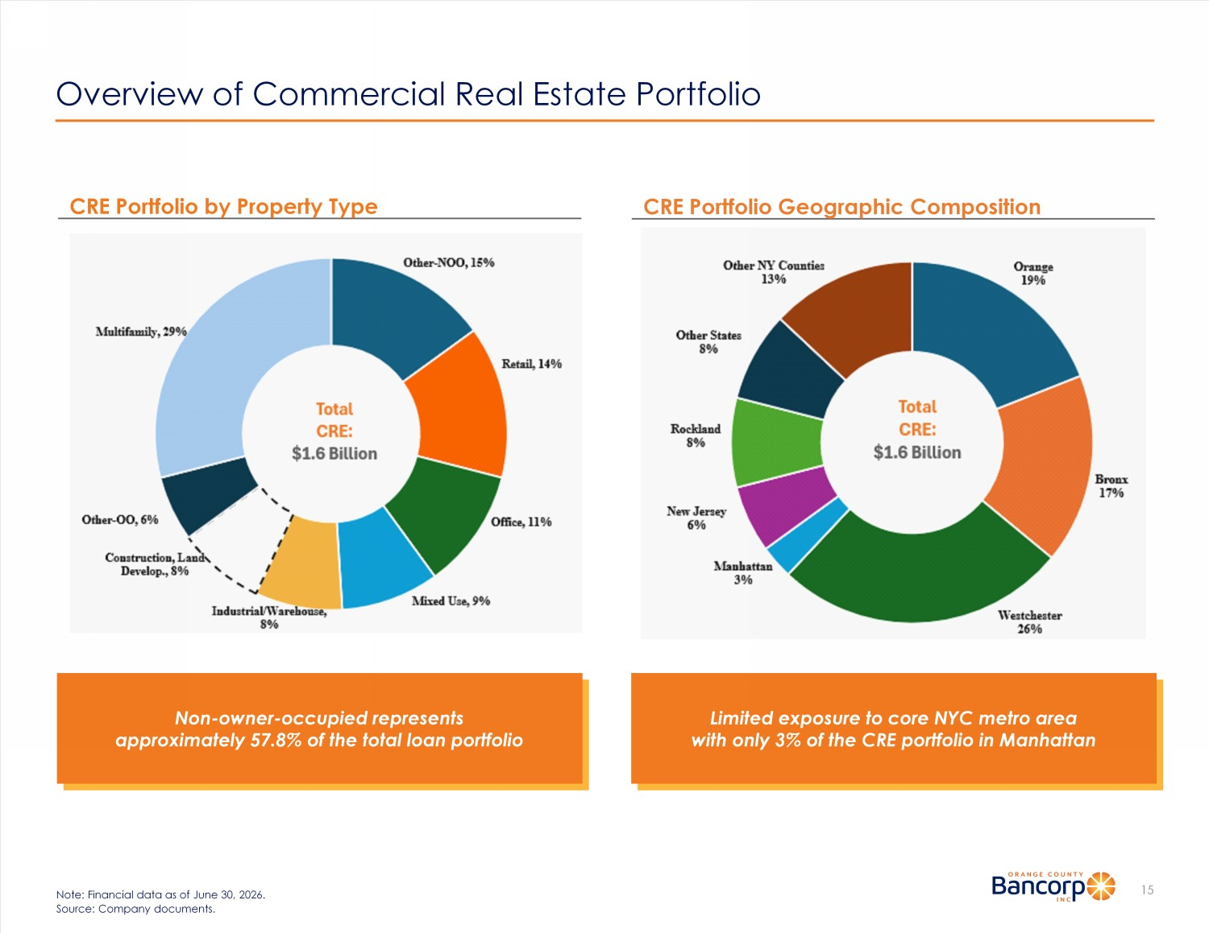
Overview of Commercial Real Estate Portfolio 15 Note: Financial data as of June 30, 2026. Source: Company documents. CRE Portfolio Geographic Composition CRE Portfolio by Property Type Limited exposure to core NYC metro area with only 3% of the CRE portfolio in Manhattan Non - owner - occupied represents approximately 57.8% of the total loan portfolio

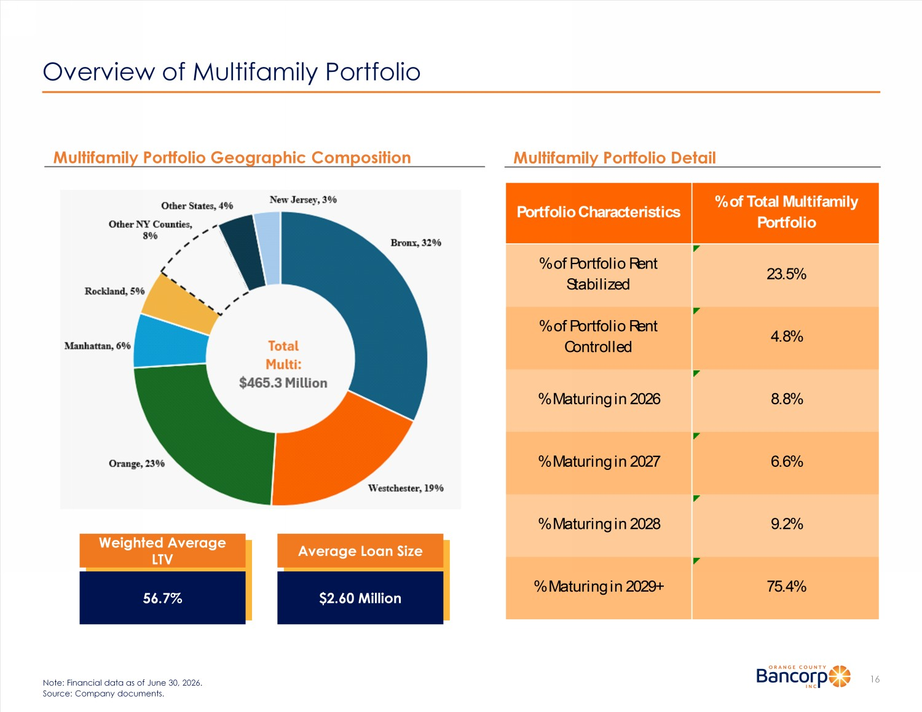
Overview of Multifamily Portfolio 16 Note: Financial data as of June 30, 2026. Source: Company documents. Multifamily Portfolio Detail Multifamily Portfolio Geographic Composition Weighted Average LTV 56.7% Average Loan Size $2.60 Million 75.4% % Maturing in 2028 % Maturing in 2029+ % of Portfolio Rent Stabilized 23.5% % of Portfolio Rent Controlled 4.8% 8.8% 6.6% Portfolio Characteristics % of Total Multifamily Portfolio % Maturing in 2027 % Maturing in 2026 9.2%

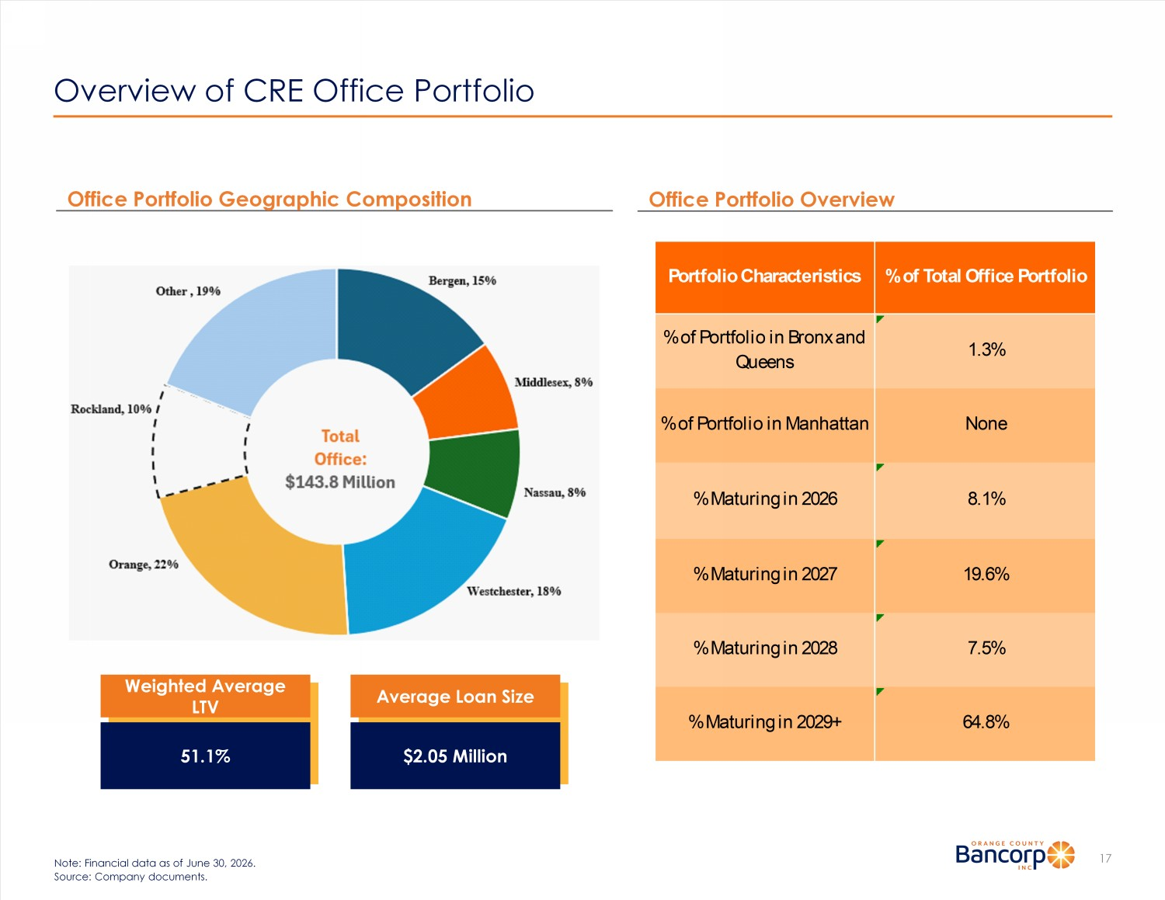
Overview of CRE Office Portfolio 17 Note: Financial data as of June 30, 2026. Source: Company documents. Office Portfolio Overview Weighted Average LTV 51.1% Average Loan Size $2.05 Million Office Portfolio Geographic Composition Portfolio Characteristics% of Total Office Portfolio % of Portfolio in Bronx and Queens 1.3% % of Portfolio in Manhattan None % Maturing in 2029+ 64.8% % Maturing in 2026 8.1% % Maturing in 2027 19.6% % Maturing in 2028 7.5%

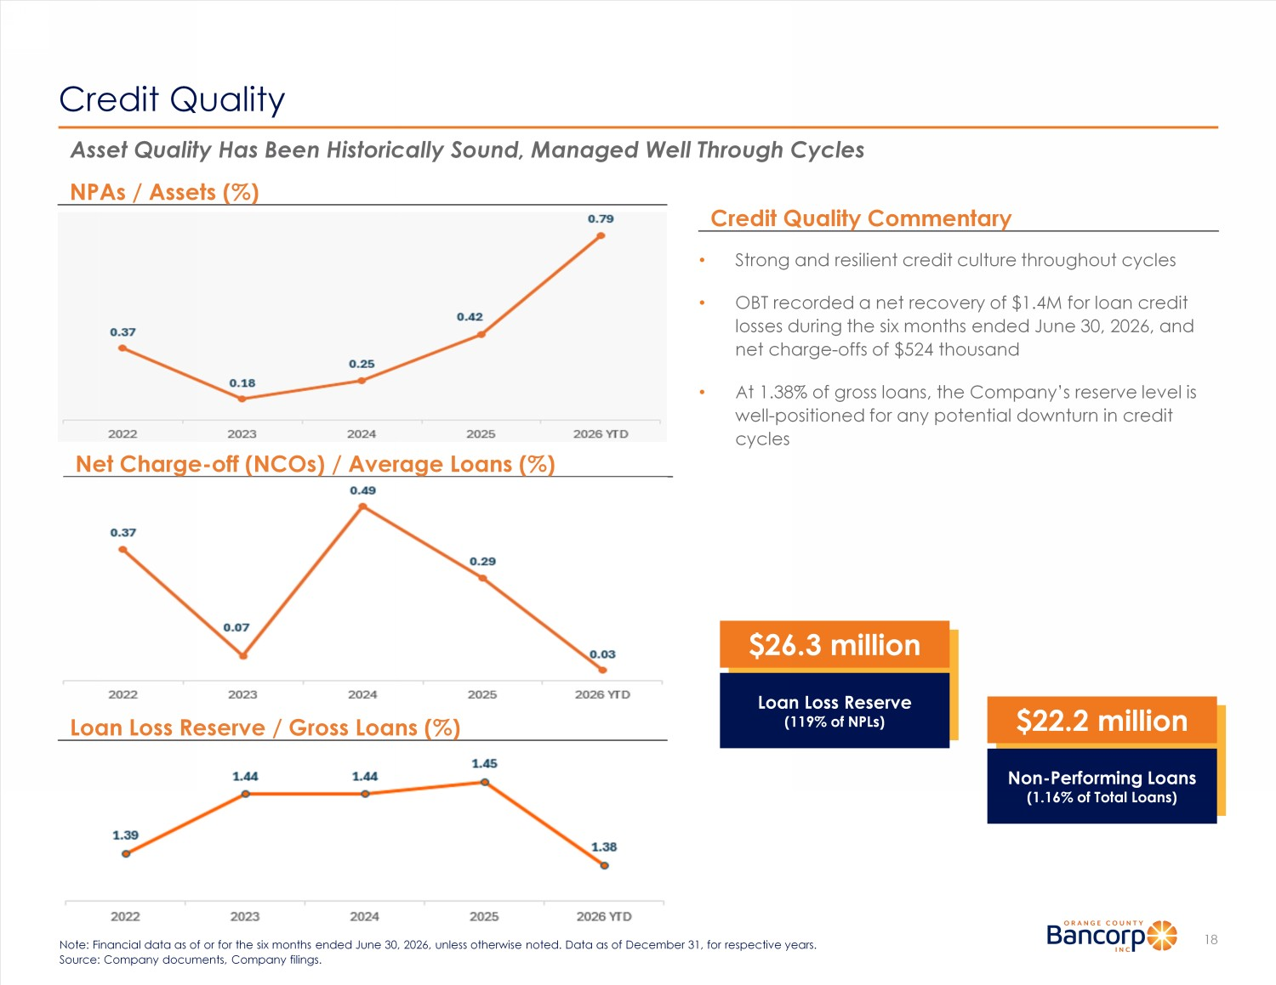
Credit Quality 18 Note: Financial data as of or for the six months ended June 30, 2026, unless otherwise noted. Data as of December 31, for res pec tive years. Source: Company documents, Company filings. Asset Quality Has Been Historically Sound, Managed Well Through Cycles • Strong and resilient credit culture throughout cycles • OBT recorded a net recovery of $1.4M for loan credit losses during the six months ended June 30, 2026, and net charge - offs of $524 thousand • At 1.38% of gross loans, the Company’s reserve level is well - positioned for any potential downturn in credit cycles Credit Quality Commentary NPAs / Assets (%) Net Charge - off (NCOs) / Average Loans (%) Loan Loss Reserve / Gross Loans (%) $22.2 million Non - Performing Loans (1.16% of Total Loans) $26.3 million Loan Loss Reserve (119% of NPLs)

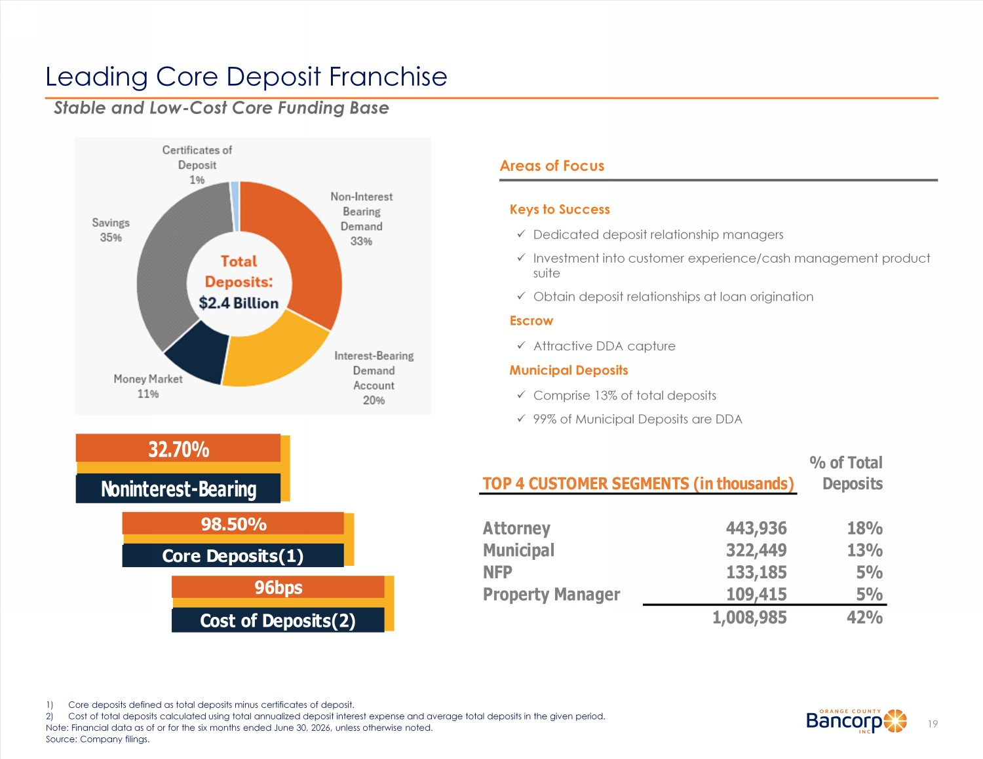
Leading Core Deposit Franchise Areas of Focus Keys to Success x Dedicated deposit relationship managers x Investment into customer experience/cash management product suite x Obtain deposit relationships at loan origination Escrow x Attractive DDA capture Municipal Deposits x Comprise 13% of total deposits x 99% of Municipal Deposits are DDA 19 Stable and Low - Cost Core Funding Base 1) Core deposits defined as total deposits minus certificates of deposit. 2) Cost of total deposits calculated using total annualized deposit interest expense and average total deposits in the given per iod . Note: Financial data as of or for the six months ended June 30, 2026, unless otherwise noted. Source: Company filings. 98.50% Core Deposits(1) 32.70% Noninterest-Bearing 96bps Cost of Deposits(2) TOP 4 CUSTOMER SEGMENTS (in thousands) % of Total Deposits Attorney 443,936 18% Municipal 322,449 13% NFP 133,185 5% Property Manager 109,415 5% 1,008,985 42%

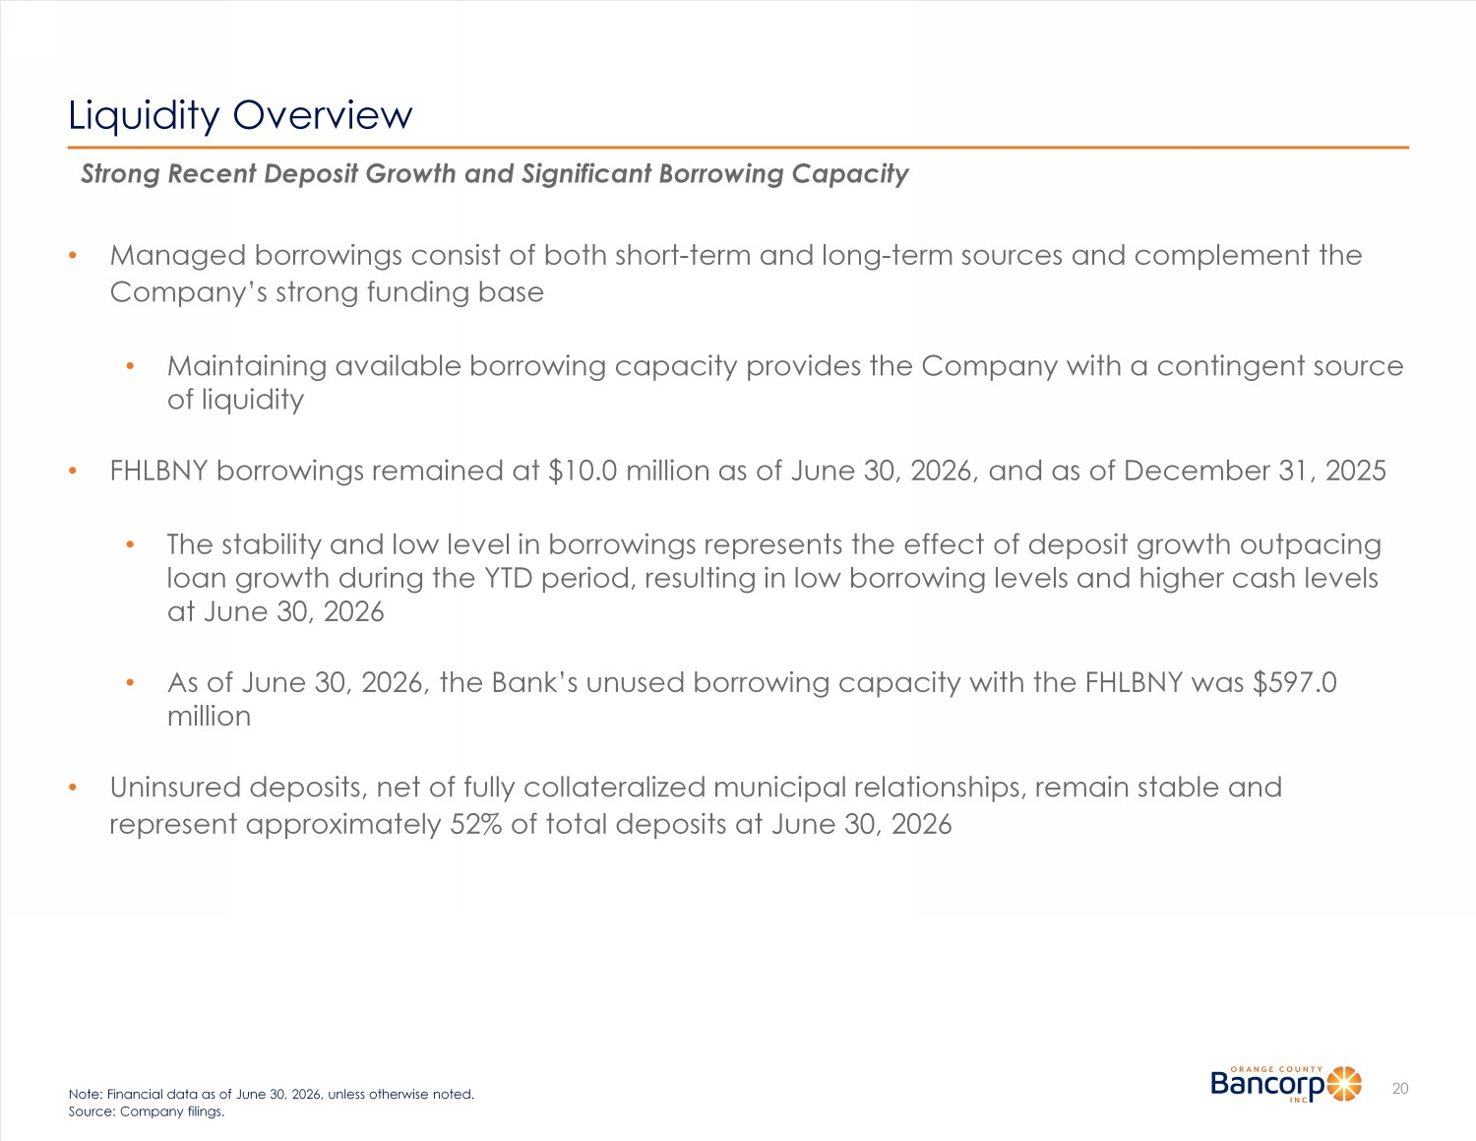
Liquidity Overview 20 Note: Financial data as of June 30, 2026, unless otherwise noted. Source: Company filings. Strong Recent Deposit Growth and Significant Borrowing Capacity • Managed borrowings consist of both short - term and long - term sources and complement the Company’s strong funding base • Maintaining available borrowing capacity provides the Company with a contingent source of liquidity • FHLBNY borrowings remained at $10.0 million as of June 30, 2026, and as of December 31, 2025 • The stability and low level in borrowings represents the effect of deposit growth outpacing loan growth during the YTD period, resulting in low borrowing levels and higher cash levels at June 30, 2026 • As of June 30, 2026, the Bank’s unused borrowing capacity with the FHLBNY was $597.0 million • Uninsured deposits, net of fully collateralized municipal relationships, remain stable and represent approximately 52% of total deposits at June 30, 2026

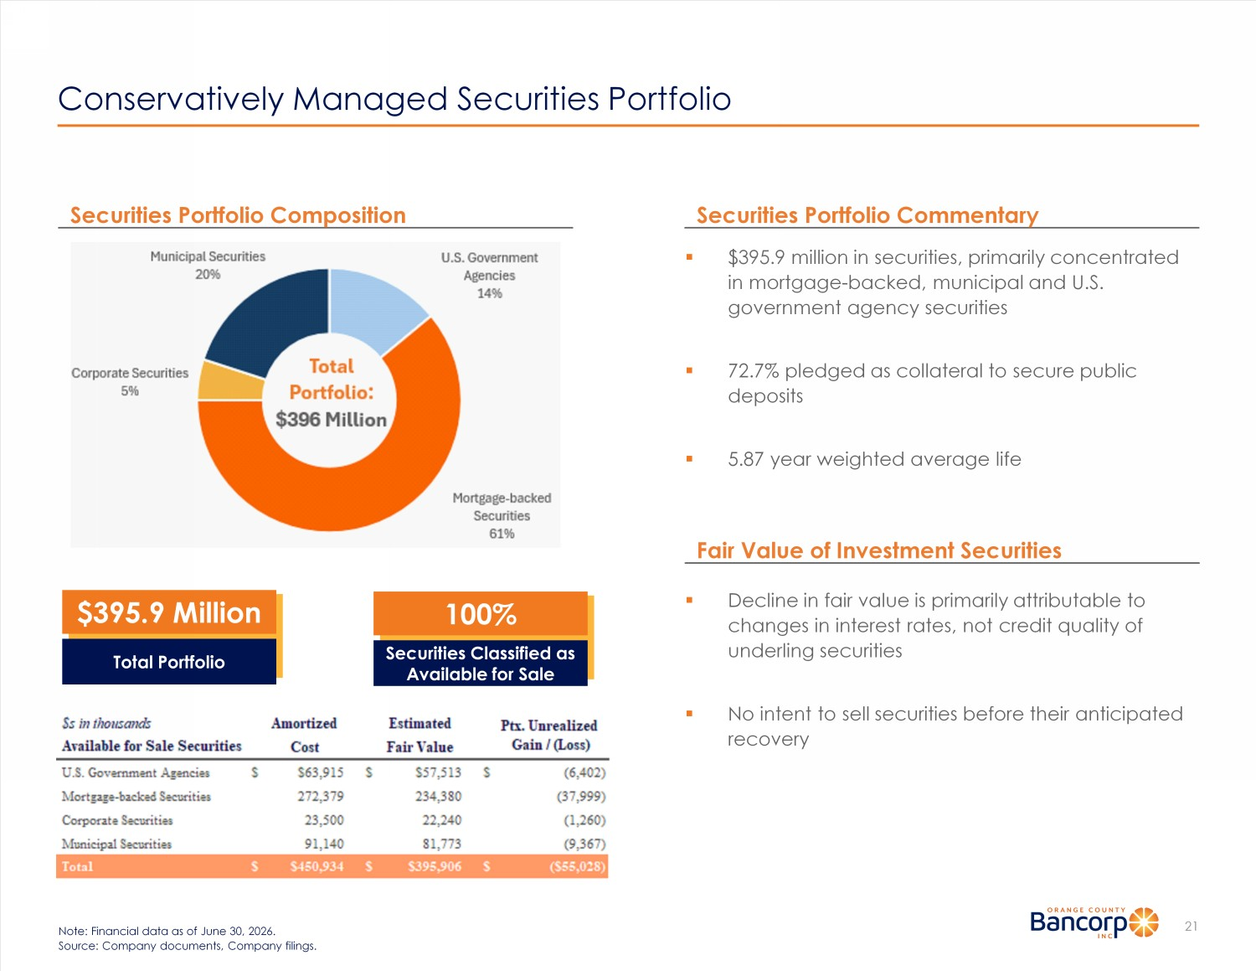
Conservatively Managed Securities Portfolio 21 Note: Financial data as of June 30, 2026. Source: Company documents, Company filings. ▪ $ 395.9 million in securities, primarily concentrated in mortgage - backed, municipal and U.S. government agency securities ▪ 72.7% pledged as collateral to secure public deposits ▪ 5.87 year weighted average life Securities Portfolio Commentary Securities Portfolio Composition $395.9 Million Total Portfolio Fair Value of Investment Securities ▪ Decline in fair value is primarily attributable to changes in interest rates, not credit quality of underling securities ▪ No intent to sell securities before their anticipated recovery 100% Securities Classified as Available for Sale

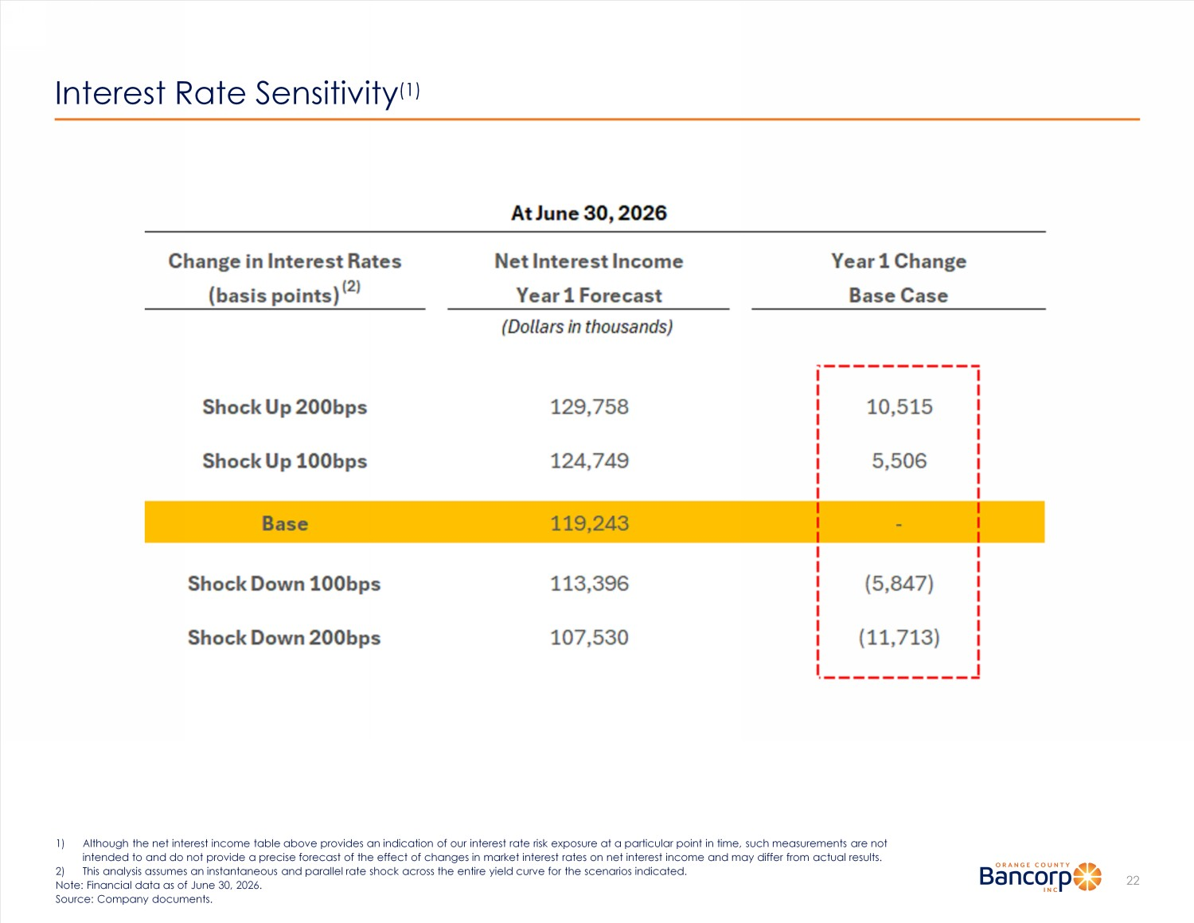
Interest Rate Sensitivity (1) 22 1) Although the net interest income table above provides an indication of our interest rate risk exposure at a particular point in time, such measurements are not intended to and do not provide a precise forecast of the effect of changes in market interest rates on net interest income an d m ay differ from actual results. 2) This analysis assumes an instantaneous and parallel rate shock across the entire yield curve for the scenarios indicated. Note: Financial data as of June 30, 2026. Source: Company documents.

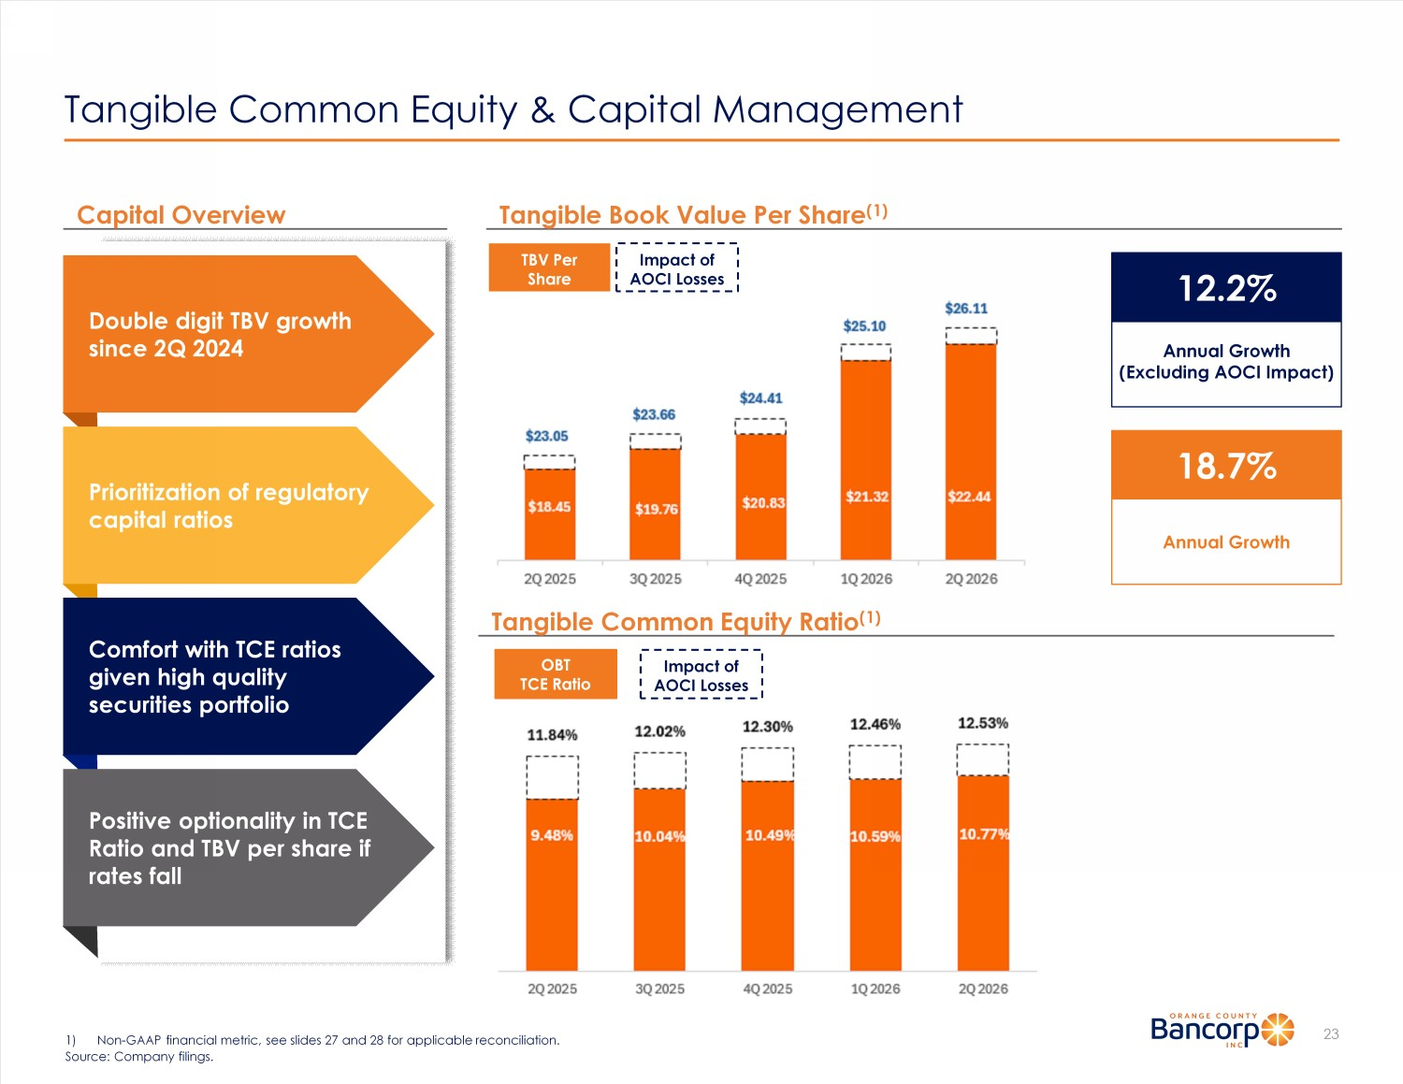
Tangible Common Equity & Capital Management 23 Tangible Common Equity Ratio (1) Capital Overview 1) Non - GAAP financial metric, see slides 27 and 28 for applicable reconciliation. Source: Company filings. Tangible Book Value P er Share (1) OBT TCE Ratio Impact of AOCI Losses TBV Per Share Impact of AOCI Losses Double digit TBV growth since 2 Q 2024 Prioritization of regulatory capital ratios Comfort with TCE ratios given high quality securities portfolio Positive optionality in TCE Ratio and TBV per share if rates fall 12 .2% Annual Growth (Excluding AOCI Impact) 18.7 % Annual Growth

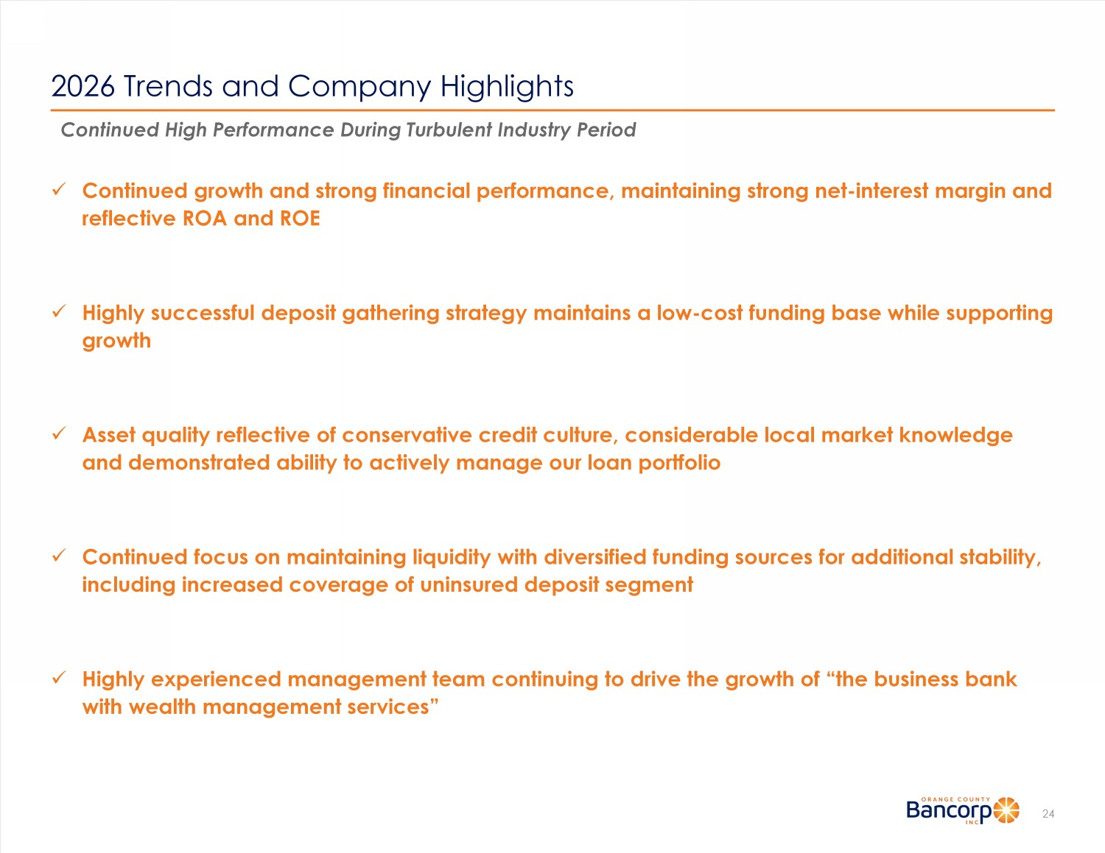
2026 Trends and Company Highlights 24 Continued High Performance During Turbulent Industry Period x Continued growth and strong financial performance, maintaining strong net - interest margin and reflective ROA and ROE x Highly successful deposit gathering strategy maintains a low - cost funding base while supporting growth x Asset quality reflective of conservative credit culture, considerable local market knowledge and demonstrated ability to actively manage our loan portfolio x Continued focus on maintaining liquidity with diversified funding sources for additional stability, including increased coverage of uninsured deposit segment x Highly experienced management team continuing to drive the growth of “the business bank with wealth management services”

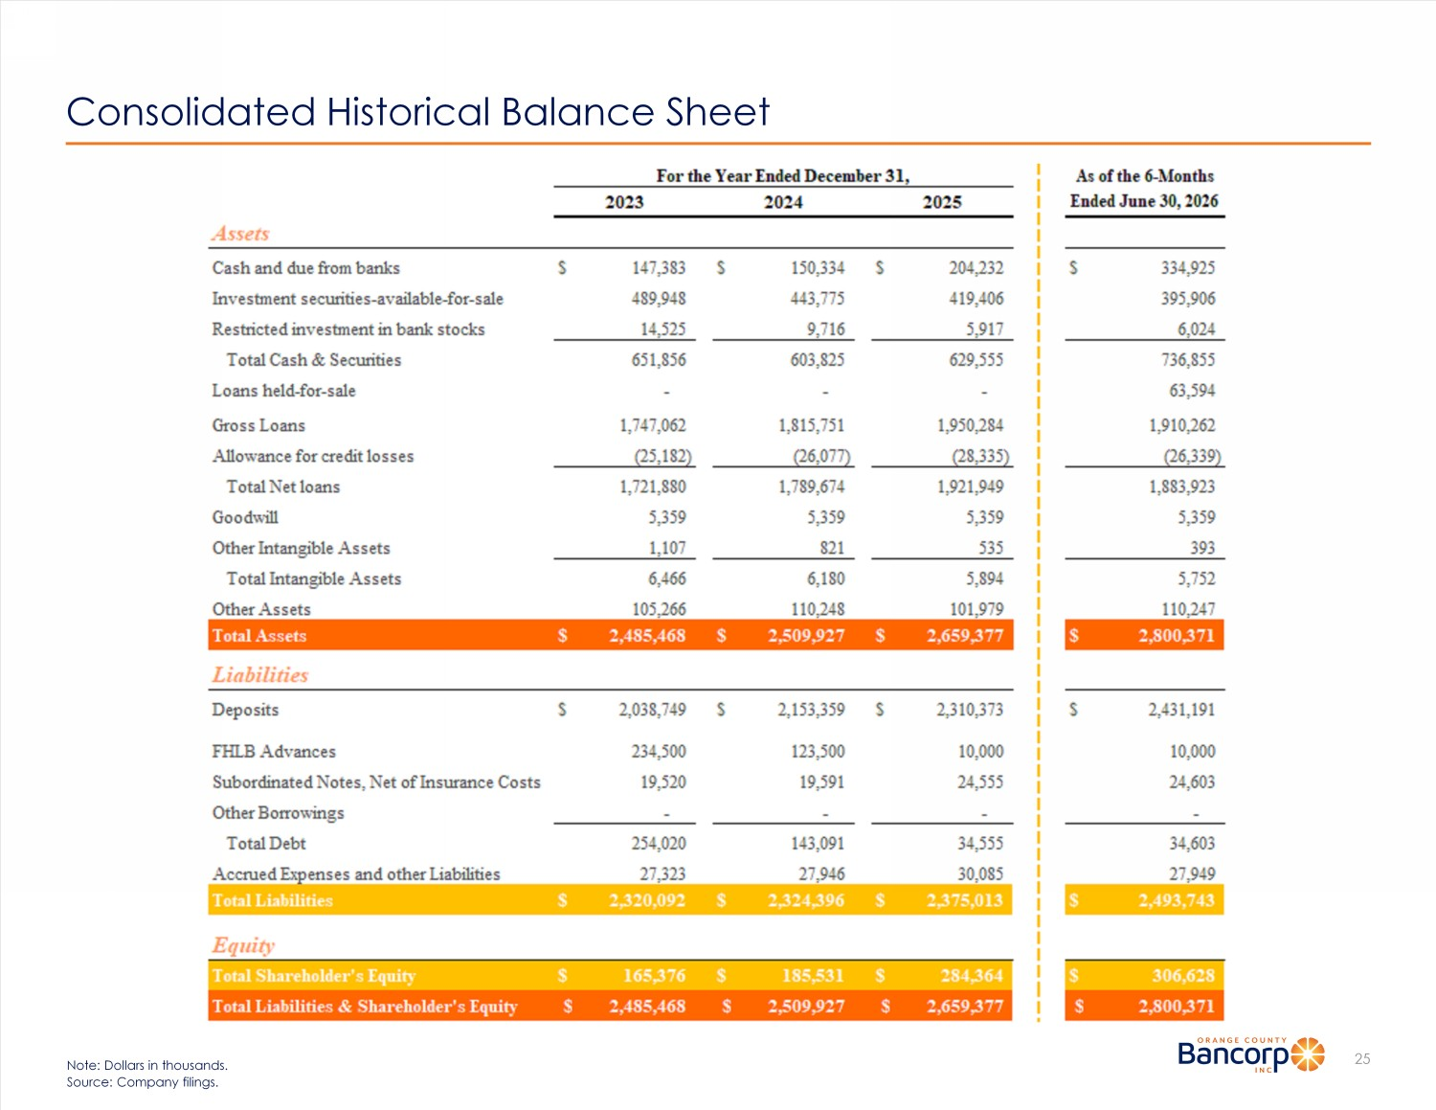
Consolidated Historical Balance Sheet 25 Note: Dollars in thousands. Source: Company filings.

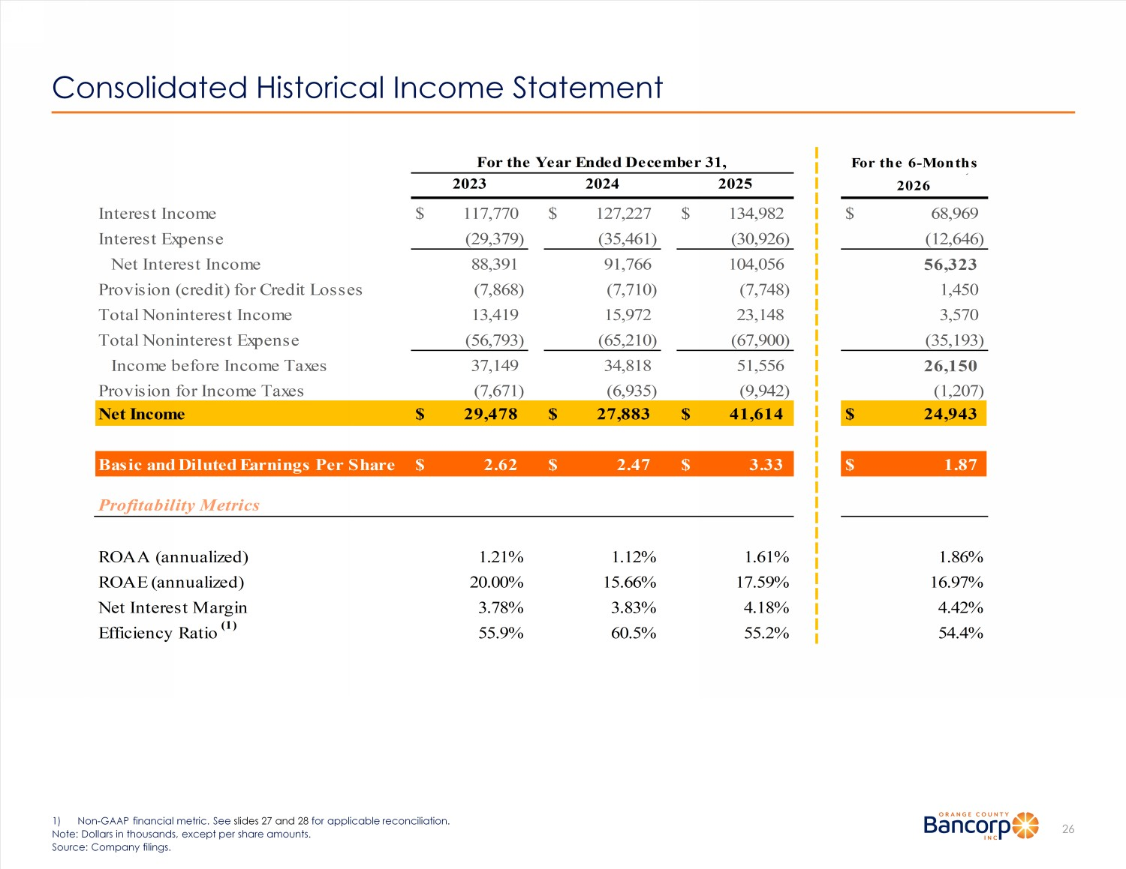
Consolidated Historical Income Statement 26 1) Non - GAAP financial metric. See slides 27 and 28 for applicable reconciliation. Note: Dollars in thousands, except per share amounts. Source: Company filings. Interest Income $ 117,770 $ 127,227 $ 134,982 $ 68,969 Interest Expense (29,379) (35,461) (30,926) (12,646) Net Interest Income 88,391 91,766 104,056 56,323 Provision (credit) for Credit Losses (7,868) (7,710) (7,748) 1,450 Total Noninterest Income 13,419 15,972 23,148 3,570 Total Noninterest Expense (56,793) (65,210) (67,900) (35,193) Income before Income Taxes 37,149 34,818 51,556 26,150 Provision for Income Taxes (7,671) (6,935) (9,942) (1,207) Net Income $ 29,478 $ 27,883 $ 41,614 $ 24,943 Basic and Diluted Earnings Per Share $ 2.62 $ 2.47 $ 3.33 $ 1.87 ROAA (annualized) 1.21% 1.12% 1.61% 1.86% ROAE (annualized) 20.00% 15.66% 17.59% 16.97% Net Interest Margin 3.78% 3.83% 4.18% 4.42% Efficiency Ratio (1) 55.9% 60.5% 55.2% 54.4% Profitability Metrics For the Year Ended December 31, For the 6-Months 2023 2024 2025 Ended June 30, 2026

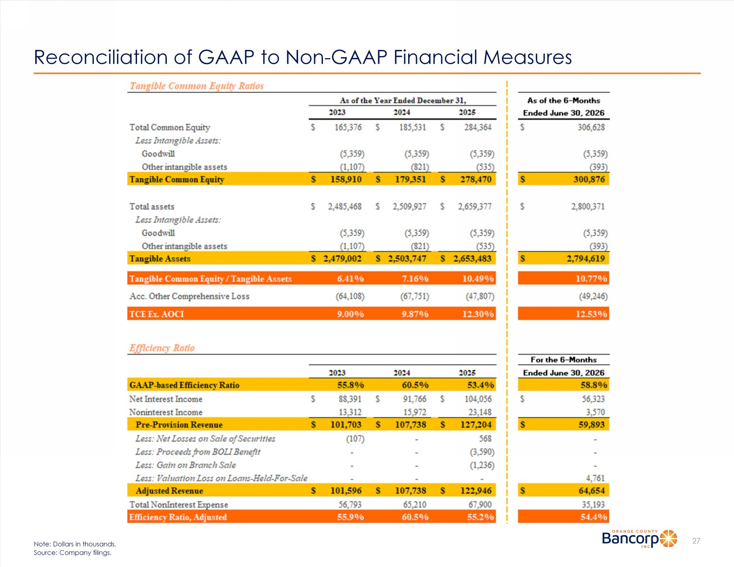
Reconciliation of GAAP to Non - GAAP Financial Measures 27 Note: Dollars in thousands. Source: Company filings.

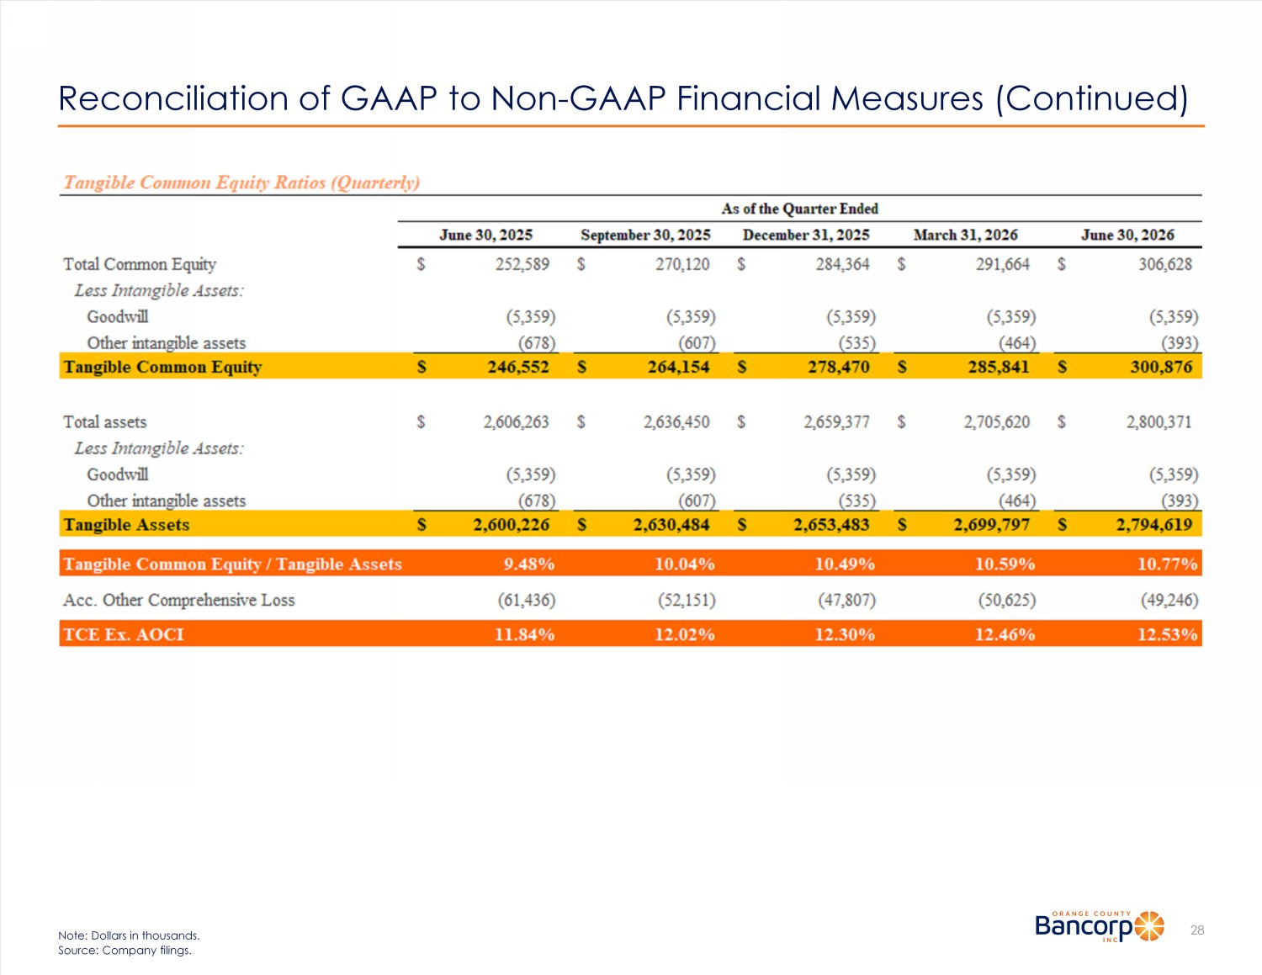
Reconciliation of GAAP to Non - GAAP Financial Measures (Continued) 28 Note: Dollars in thousands. Source: Company filings.

